*COD’:*

*Calculated oxygen demand,* normally is equal to the *chemical oxygen demand (COD).*The ratio of oxygen required for full oxidation of the cellular carbon per unit weight of cells.

True yield (Y): page 149

The fraction fs° can be converted into mass units, such as g cell produced/g COD' consumed. When expressed in mass units, it is termed the true yield and given the symbol Y. The conversion from fs° to Y is

Y= *fs° (Mc* g cells/mol cells)/ [(nee- eq/mol cells) (8 g COD/e- eq donor)]

*Mc* =the empirical formula weight of cells

*ne=* the number of electron equivalents in an empirical mole of cells

COD = the donor mass is expressed as COD.

Xa= active organism

b = the decay rate

Yn= net yield

The net yield is less than *Y,* because some of the electrons originally present in the substrate must be consumed for energy of maintenance. When considering net yield, the portion of electrons used for synthesis is *fs* rather than *fs°,* and the portion for energy generation is *fe* rather than *fe0 .* Still, the sum of *fs* and *fe* equals 1, and *fs* < *fs0'* while *fe* > *fe0 .*

Electron donor = the "food" substrate for organisms.

1. Organic matter.
2. reduced inorganic compounds, such as ammonia and sulfide

Electron acceptor

1. under aerobic conditions = molecular oxygen (02)
2. Under anaerobic conditions = nitrate, sulfate, and carbon dioxide.

*\*\* In some cases, organic matter is used as the electron acceptor, as well as the electron donor, and the reaction is then termed fermentation\*\**

Order of preference for electron acceptors =

Oxygen>nitrate> sulfate>carbon dioxide (methanogenesis)>fermentation

Energy production 🡺 electron donor

Bacterial growth

Cellular synthesis 🡺

* Rc = half-reaction for synthesis (Table 2-4)
* acceptor half-reactions
* Ra= acceptor half-reactions (Table 2-4) for the five most common electron acceptors: 02, N03, Fe3+, SO43-, and CO2
* Re = The energy reaction,
* Rd= donor half-reaction
* Rs = synthesis reaction

Re = Ra - Rd

Rs = Rc - Rd



** The equation represents the net consumption of reactants and production of products when the microorganisms consume one electron equivalent of electron donor.

***Ammonium is the preferred nitrogen source

One equivalent of oxygen is 8 g of 02, one equivalent of any electron donor is equivalent to an OD of 8 g as O2 (8 g OD/e- eq)

Microbial yield from substrate utilization

1. energy reaction 🡺 creates high-energy carriers (ATP)
2. energy carriers are "spent" to drive cell synthesis or cell maintenance
3. energy costs of cell synthesis and
4. the energy lost in transfers

∆G*s=* the energy required to synthesize one equivalent of cells from a given carbon source when the nitrogen source is ammonium.

∆G*p=* The energy required to convert the carbon source to pyruvate

∆G0*c=* free energy of the carbon source as the electron donor (table 2.3)

∆G*pc=* The energy required for Pyruvate carbon to converted to cellular carbon = 3.33 kJ per gram cells * electron equivalent of cell (PG173)





***∆Gp ≤0 🡺 n= -1 & ∆Gp>0 🡺 n= +1

Heterotrophic bacteria= carbon source is the electron donor

Autotrophic reactions = carbon source is inorganic carbon (more energy)

∆G*r=* the free energy released per equivalent of donor oxidized for energy generation.

A =the equivalents of donor used for energy production per equivalent of cells formed

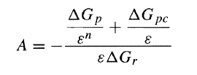

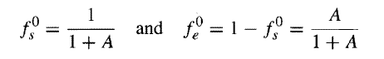

**Microbial Kinetic**

* Rate-limiting **substrate** is the **electron donor**

Bacterial growth kinetic (*Monad equation*):

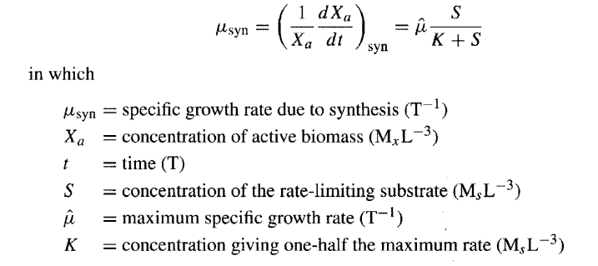



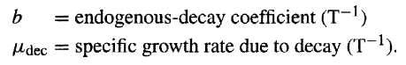





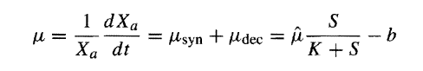

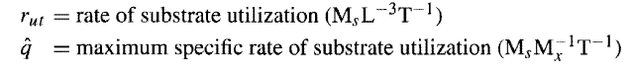

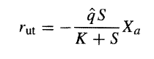









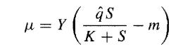

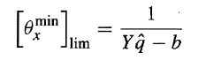

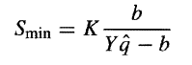

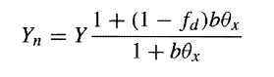

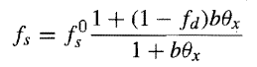

***Some biological processes receive significant inputs of biomass active in degradation of the substrate***

θx is now defined with the denominator being the gross active biomass output rate (QXa) minus the input rate (QXa0). Thus, the denominator remains the net production rate of new active biomass.(PG204)

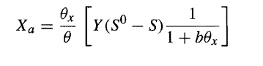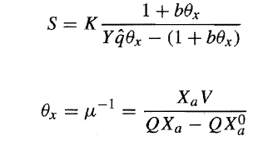

When θx is: (PG 190)

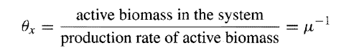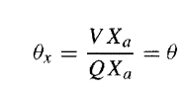

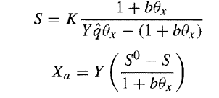

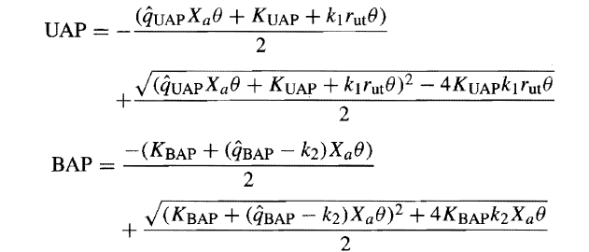

Mass balance on CSTR with sludge recycle: (PG301)

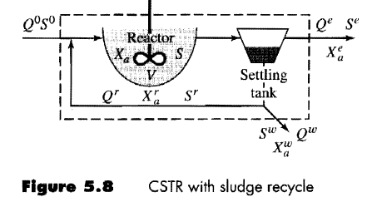

Xra = The concentration of microorganisms in this recycle line

Xea = The concentration of microorganisms in the effluent

Xwa = waste sludge to be removed

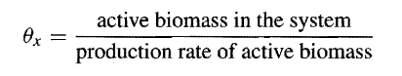

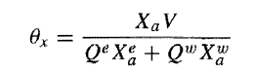 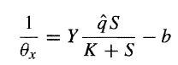

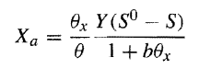 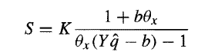

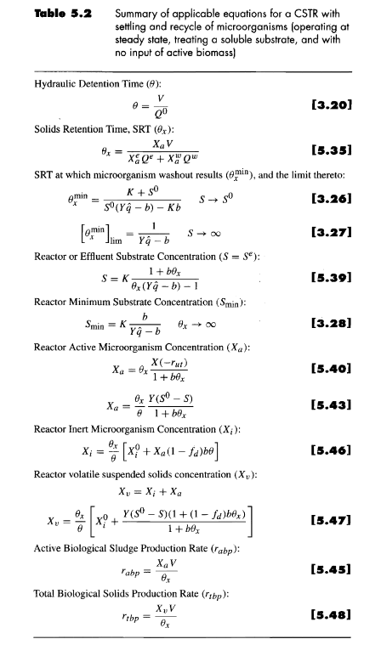

θxd = Design θx



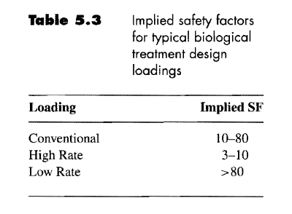

**Activated sludge:**

The food-to-microorganism ratio **(F/M)** is:

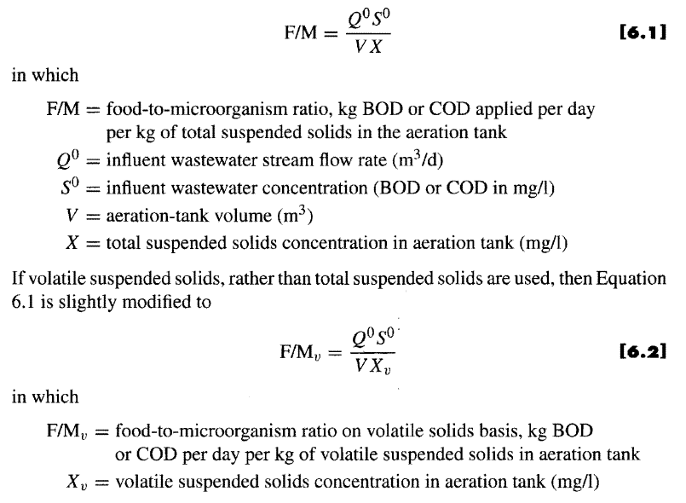

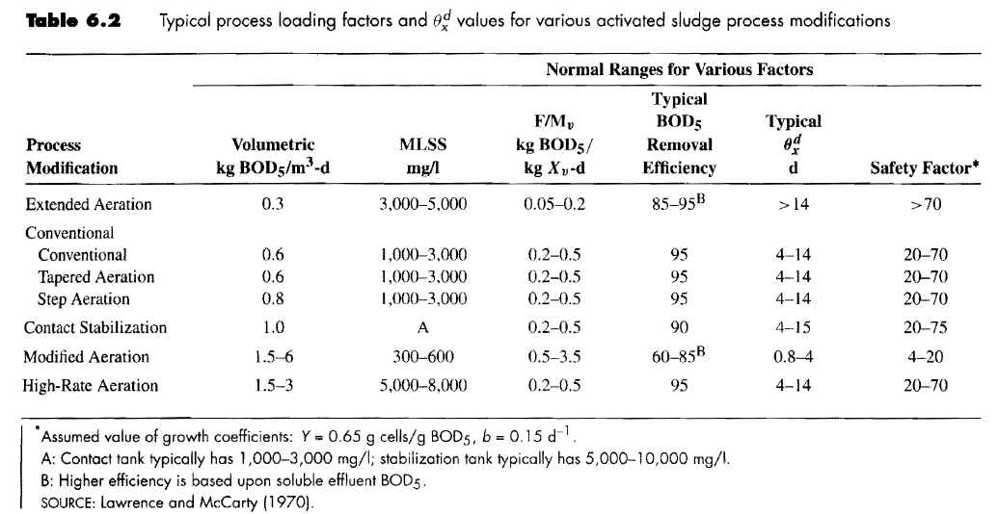

X= Mixed-liquor suspended solids concentration, or *X,* to select for the aeration tank

SVI = is defined as the volume in milliliters occupied by 1 g of the suspended solids after settling.

**Nitrification**

Nitrification conditions:

1. considered impossible for low-water temperatures(if t low => θ high Pg. 252)
2. highly efficient, as long as the SRT is maintained well above θminx
3. Sufficient dissolved oxygen is present.

Other important features of nitrification.

1. It creates a major oxygen demand.
2. It produces almost two strong-acid equivalents per mole of NH4 removed.
3. Slow growth rate

*** The two disadvantages are overcome by ensuring that the nitrifiers have a long SRT, typically greater than 15 d, although larger values may be needed in the presence of toxic materials, a low D.O. concentration, or low temperature.

**Anammox Process (**Anaerobic Ammonium Oxidation)

* to anaerobically oxidize *NH4+*-N to N2, not to N02-

Anammox Process Conditions:

1. exceptional biomass retention (to give a very long SRT)
2. stable operation
3. presence of nitrite
4. lack of oxygen
5. lack of donors that could cause the reduction of nitrite via denitrification

**Denitrification**

* Denitrification is the dissimilatory reduction of N03- or N02- to (mainly) N2 gas

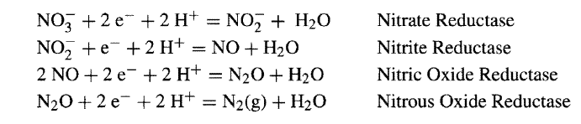

Accumulation of intermediates:

1. Very low concentrations of the electron donor
2. too high concentrations of D.O. concentration
3. pH values outside the optimal range of7 to 8 can lead to accumulation of intermediates

** High NO3--N levels occurred in waters that had little or no BOD, Thus, research addressed exogenous electron donors and carbon sources. Simple compounds that can be purchased in bulk quantity were evaluated: methanol, acetate, glucose, ethanol, and a few others.Because methanol (CH30H) was relatively inexpensive, it gained widespread use, and a very large database on methanol has been developed. Being a one-carbon compound (Pg. 551)

** The heterotrophic denitrifiers have kinetic characteristics similar to aerobic heterotrophs.

Heterotrophic Denitrifiers VS Autotrophic Nitrifiers:

1. nitrifiers much slower growers, and require substantially longer solids retention times
2. maximum nitrification rates require a high D.O. concentration, while high D.O. concentration slows or stops denitrification

Denitrification by activated sludge:

1. The reactor is design to minimize aeration.
2. supplementation with electron donor is required

** Rule of thumb is 4 g *BODL/g* NO3--N removed through denitrification. Extra electron donor must be supplied if 02 enters the system.

**Phosphorous removal**

Enhanced biological phosphorus removal:

1. *Anaerobic bioreactor:* Electron acceptors-particularly 02 and N03-must be excluded to the maximum degree possible so that BOD oxidation is insignificant in this reactor. (bacteria are able to take up simple organic molecules and sequester PHB, hydrolysis of poly P, release of phosphorous)
2. Ample electron acceptors are available through aeration, which directly supplies O2 and al1ows generation of NO3-, if nitrification occurs.(ATP is generated)